**Required Request Data and Response Data from Server**

## Register user (teacher/ admin/ super admin)

**Request data: -**

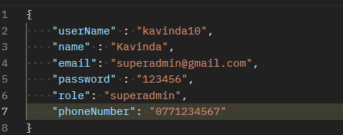

* userName: string
* name: string
* email: string
* password: string
* role: user/ admin/ superadmin
* phoneNumber: string

**Response data: -**

* userName: string

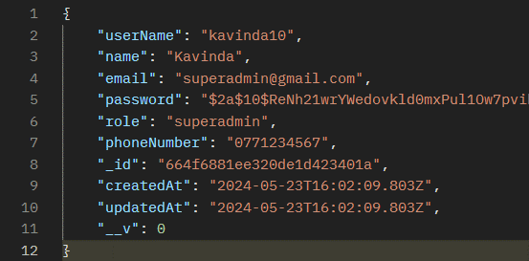

* name: string
* email: string
* password: string
* role: user/ admin/ superadmin
* phoneNumber: string
* _id: string
* createdAt: string
* updatedAt: string
* _v: number

## Login user (teacher/ admin/ super admin)

**Request data: -**

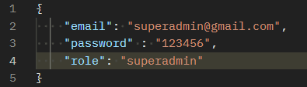

* email: string
* password: string
* role: user/ admin/ superadmin

**Response data: -**

* _id: string
* userName: string

* name: string
* email: string
* role: user/ admin/ superadmin
* phoneNumber: string
* createdAt: string
* updatedAt: string